**5.0 SYSTEM DESIGN**

* 1. **SYSTEM APPLICATION DESIGN**
     1. **Method Pseudo code**

1)First login

2)Teacher post campus drive

3)Student sees the post and enroll in it.

4)Teacher takes attendance at the campus drive.

5)Student gives attendance by scanning qr code.

6)Teacher gives result of each round.

7)Student gets notification of results.

8)The report is generated from firebase.

* 1. **DATABASE DESIGN/DATA STRUCTURE DESIGN**
     1. **Table and Relationship**

Table Company

-id

-location

-name

-website

-requirements

-date

-time

-round1location

-round2location

-round3location

-roundtime

-round2time

-round3time

Table enrolment

-username

-companyid

-round1result

-round2result

-round3result

-round1attendance

-round2attendance

-round3attendance

Table user

-username

-emaiL

* + 1. **Logical Description Of Data**

Company

Id: unique identification of company

Location: geographic location of company

Name: Name of company

Website: website of company

Date: date of recruitment

Time: time of campus drive

Round1location: location in charusat campus of company’s round1 interview

Round2location: location in charusat campus of company’s round2 interview

Round3location: location in charusat campus of company’s round3 interview

Round1time: time of round 1

Round2time: time of round 2

Round3time: time of round 3

Enrolment

Username: user name of student who enrolls

Companyid: company name for which user is enrolling

Round1result: result of round 1

round2result: result of round 2

round3result: result of round 3

round1attendance: attendance of student in round 1

round2attendance: attendance of student in round 2

round3attendance: attendance of student in round 3

User

Username:charusat id of student

Email:charusat email address of student

* 1. **INPUT/OUTPUT AND INTERFACE DESIGN**
     1. **State Transition Diagram**

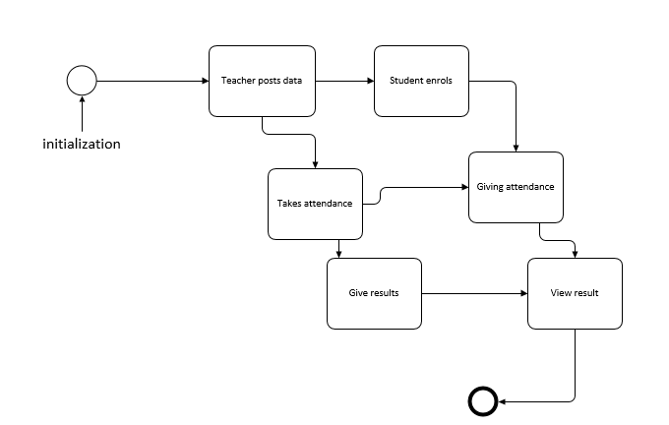

* + 1. **Samples Of Forms, Reports and Interface**

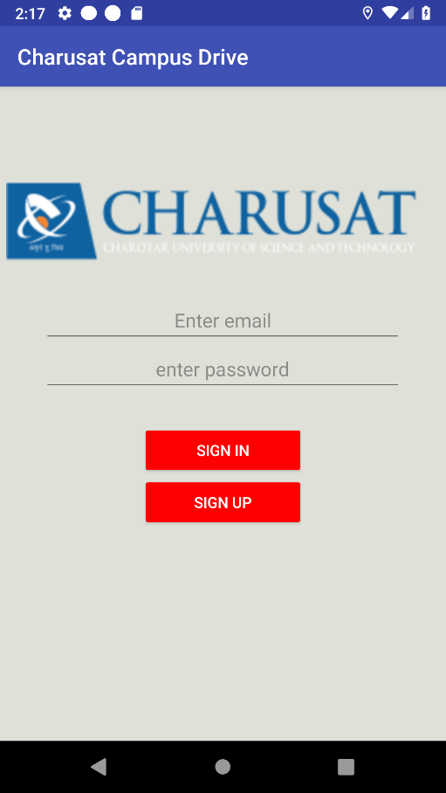

Figure 3:sign in page

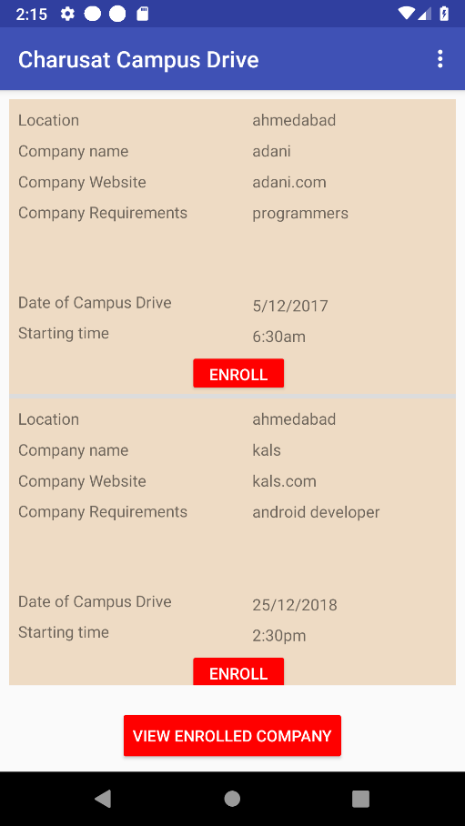

Figure 4:enrolment page

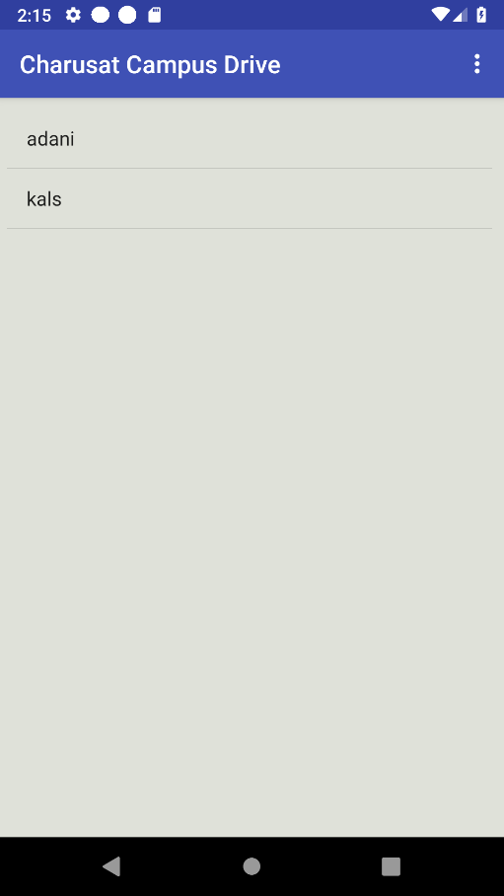

Figure 5:view enrolled company page

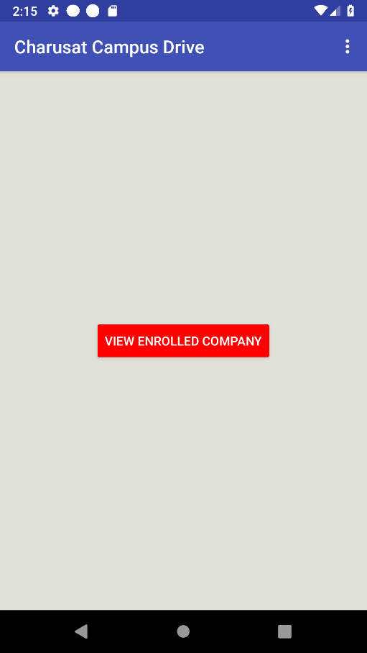

Figure 6:view enrolled company

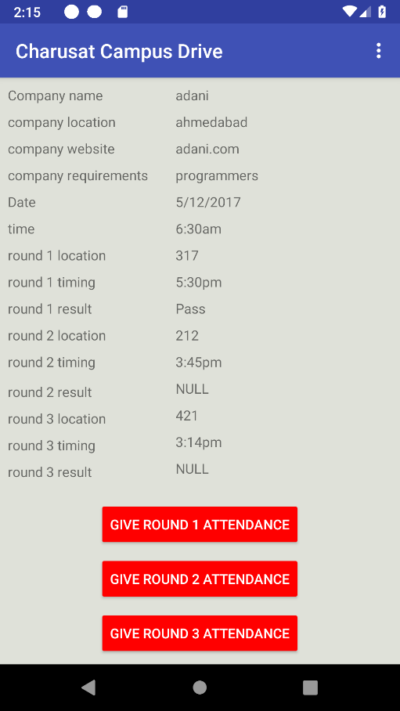

Figure 7:viewing details about enrolled company

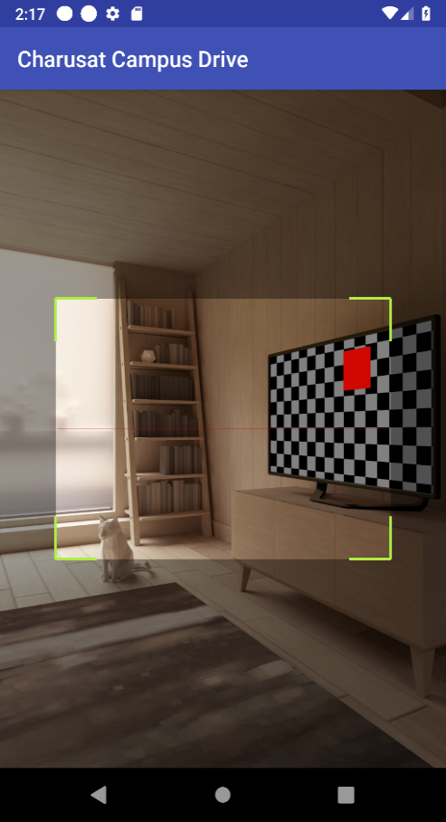

Figure 8:scanning qr code

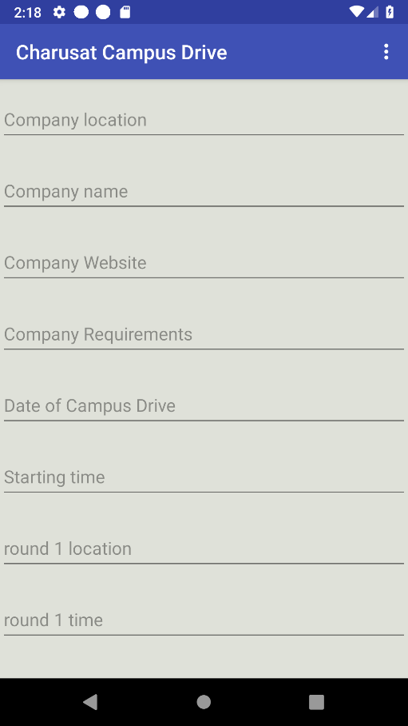

Figure 9:post campus drive

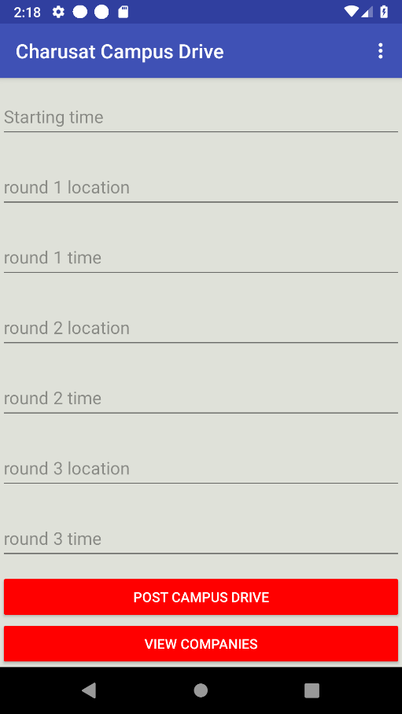

Figure 10:post campus drive detail

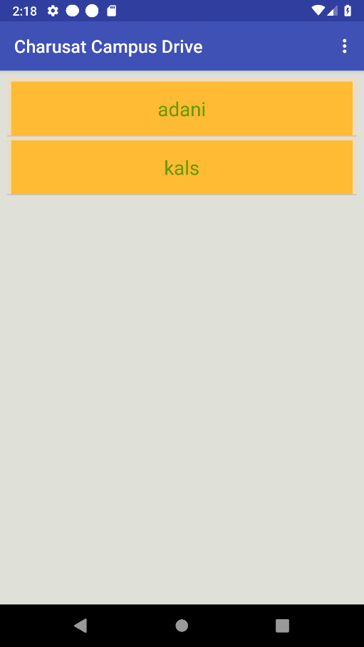

Figure 11:view posted companies

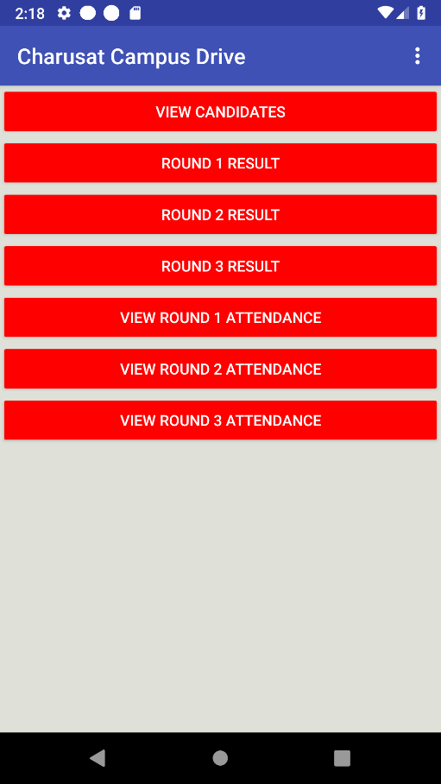

Figure 12:teacher menu

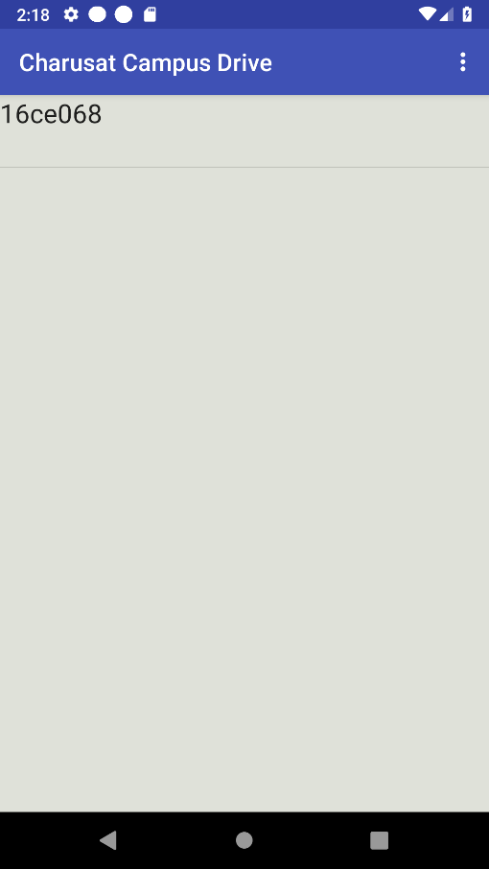

Figure 13:view enrolled students

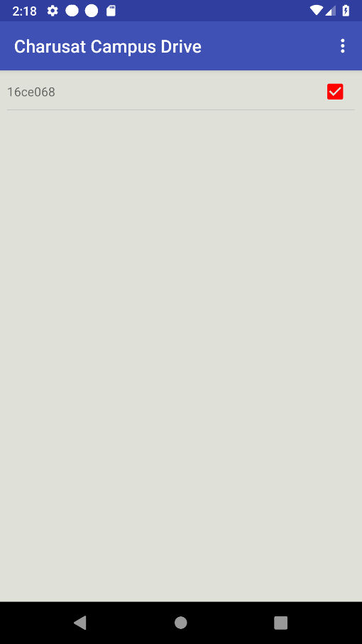

Figure 14:Result anouncment activity